CS-005 CNC Machining of Tooling Board (ShopSabre)
Doc ID | CS-005
Title | CNC Machining of Tooling Board — ShopSabre @ RFS
Revision | E
Status | Draft, pending Lead signature
Effective date | 2026-08-28
Supersedes | Jacobs Shopbot as primary mold machine (see Appendix); Shopbot Procedure Checklist still applies to the Shopbot when we use it

Approvals
Role | Name | Date
Author | Simon Starbuck (drafted with Claude, SN6 Resources) | 2026-07-12
Reviewer | simon (reviewer agent) | 2026-07-12
Approver (Composites Lead)

Revision history
Rev | Date | Author | Description of change
A | 2026-07-12 | Claude | Initial issue
B | 2026-07-13 | Claude | Corrected machine facts: 5×10 bed (not 4×8), vacuum hold-down, automatic tool changer w/ auto tool measurement; zeroing section rewritten around the ATC
C | 2026-07-28 | Claude | Added a dated 2026-07 web cross-check on the R2 ShopSabre spec citation (doesn't resolve the placard-confirm open item, just documents it); sharpened the certified-operator list caveat against a real discrepancy found in sn5-work-orders.json. Language pass (fewer em dashes, less decorative bold).
D | 2026-08-03 | Claude | §7.5 now engraves the mold ID on the back face before releasing the vacuum, while the setup still exists. This is the record of record (CS-001 §7.4).
E | 2026-08-28 | Claude | Engineering pass (CS-000 Rev C conventions). Figure 1 draws the Z-zero rule right and wrong; it replaces the photo placeholder, which showed the same thing less clearly. No rule changed.

1. Purpose
We spent most of SN5 machining molds on the Jacobs Shopbot's daily slot scramble, right up until Jacobs staff pulled us aside for block-reserving (2026-02-23). That's not a conversation we want to have twice (PP-06). We now machine on the ShopSabre at RFS, with our own reservation system, a 5×10 ft bed, vacuum hold-down, and an automatic tool changer. This doc covers how to book it, who can run it, and the setup rules that cost us parts when we skipped them.

2. Scope
Machining polyurethane tooling-board molds and stock on the RFS ShopSabre. The Jacobs Shopbot is still fine as a fallback for small jobs; use the SN5 Shopbot Procedure Checklist there (that machine has none of the features below; everything is manual).

3. References
Ref | Document | Where
R1 | RFS/RSO reservation website (booking) + ShopSabre training doc | RFS website
R2 | ShopSabre 5×10 specs (IS-A 510 class) | shopsabre.com product pages, accessed 2026-07. Re-checked 2026-07-28: the current IS-A 510 page quotes a 75″×125″ table and 12″ Z clearance / 16″ Z travel, which doesn't line up cleanly with the 65.5″×122″ / 6″ / 14″ figures below. Treat both as generic spec-sheet numbers, not a measurement of RFS's specific machine with its actual tooling stickout; confirm the real numbers on the placard before trusting either source over field experience
R3 | Shopbot Procedure Checklist (fallback machine) | SN5 Drive root
R4 | PP-06 RCA; Z-plunge incidents | FEB-COMP-PP-001
R5 | CS-003 (mold design/stock), CS-004 (post-machine cleaning) | this series

4. Definitions
- HOT: RFS hands-on-training sign-off; required before you run the machine on your own.
- Certified operator: did the RFS ShopSabre training doc + HOT. End-of-SN5 list: Ansh, Simon, Kina, Nico, Nick, Justin, Sam, Alvin, Ernesto. Treat that list as a historical snapshot, not a current roster: nothing in this repo tracks HOT status, and it's already out of step with the only other named-individual record we have (2026-07-28 check: sn5-work-orders.json's engineer fields name people, like Chuning, who aren't on this list at all; a WO engineer credit isn't the same thing as ShopSabre certification, so that's not a fix, just a flag). RFS's own HOT record is the actual authority. Re-check who's still around each fall and train replacements early, October not February.
- CAM review: Larry requires whoever is machining to have made their own CAM, and he reviews it before it runs. Build this into the schedule; it has saved us more than it has cost us.
- ATC: automatic tool changer. The machine swaps tools from its rack mid-program and measures each tool's length automatically, so tool changes don't need a manual re-zero.

5. Equipment & Materials
Item | Spec | Notes
ShopSabre CNC router (5×10) | Cut area ≈ 65.5″ × 122″; max cut depth ≈ 6″ in practice; Z travel 14″ (R2, field figures, not the current shopsabre.com spec page; see R2 note) | Full 5×10 sheets fit flat: no more sectioning sheet stock. Mold stacks taller than ~6″ still need splitting in CAD (CS-003 §7.1.6). The 6″ is what this team has actually gotten out of the machine with real tooling installed, which is the number that matters here, not a frame spec; confirm usable depth against your tool length before gluing a tall stack
Vacuum hold-down table | Zoned vacuum through the spoilboard (R2) | Sheet stock and boards hold with no tape or nails. See 7.3 for when vacuum alone isn't enough
Automatic tool changer | Tool rack + automatic tool length measurement (R2) | Tool offsets live in the controller's tool table; see 7.4
End mills / collets | Per CAM plan | Inspect before use; tell Larry if a tool in the rack looks tired
Dust extraction | Machine system | PU dust rules in §6

6. Safety
- Machine: hands away from a live spindle; know where the e-stop is before every run; watch the first minutes with a hand near it. Max 2 people at the machine during setup (kept from the Shopbot rules; still a good rule).
- Tooling-board dust: abrasive and irritating. Extraction on, dust mask minimum (respirator for long jobs). Vacuum shared rooms; don't blow dust around with compressed air.
- Vacuum table: don't reach under a held part to "check" it while zones are on; release zones first.

7. Procedure

7.1 Plan and book (the PP-06 discipline)
- When mold CAM starts (not when it finishes), put the machining time estimate on the WO and book the slot on the RFS/RSO site (R1). Our SN5 UT molds ran 0:17–6:16 each; CAM simulation gets you a real number.
- Book under the name of whoever is actually running the machine. RFS rule: you attend your own reservation. No covering slots for each other; that's the exact thing that burned us at Jacobs.
- Booking-site quirks (as of spring 2026): multi-day and some short blocks fail: book day-by-day chunks and report bugs to Joey.
- The weekly summary carries the next 2 weeks of machine load so conflicts show up Monday night, not at the machine.

7.2 Prerequisites at the machine
- Certified operator, running their own CAM, reviewed by Larry (R1).
- Mold design review initialed on the WO (CS-003 §7.2). No initials, no cutting.
- Stock glued/cured per CS-003 §7.3 and labeled, and check the label is actually the job you booked.

7.3 Workholding (vacuum table)
- Sheet stock and flat boards: place on the spoilboard, open the zones under the part, keep unused zones closed for suction where it counts. No tape, no nails.
- Tall glued mold stacks with small footprints are the case to think about: holding force scales with footprint area, and a 6″ stack on a small base sees real side loads. Do a firm hand-push test before running; if it moves at all, add mechanical fixing (screws through waste margin into the spoilboard, or cleats) and note it in the CAM so nothing cuts there.
- Porous/already-sealed surfaces hold differently. When in doubt, test-push and ask Larry.

7.4 Zeroing and tooling: where SN5 lost parts
- Zero Z once per job, from the top of the stock, at the highest point of the finished stack. Never the bed. (The Feb 2026 "it plunged into the part" incidents were zeroing mistakes on the old machine; the rule carries over.)
- Tool changes are the ATC's job, not yours. The machine measures each tool's length and applies offsets from the tool table: there's no manual re-zero between tools. What that means for you:
- Make sure your CAM tool numbers match what's physically in the rack. A mismatched tool table does the same thing a bad zero does, just faster.
- If anyone has manually swapped a bit in a rack position, the tool must be re-measured before your program trusts it. When in doubt, run the tool-measure cycle; it costs a minute.
- Verify X/Y zero against the stock corner and the CAM origin before starting.
- Deep cuts: split toolpaths into depth stages rather than one full-depth pass.
- Watch the first minutes of every program, hand near the stop.
⚠ CAUTION: Machine doing anything unexpected: stop first, figure it out second. A scrapped hour is cheaper than a scrapped mold stack.
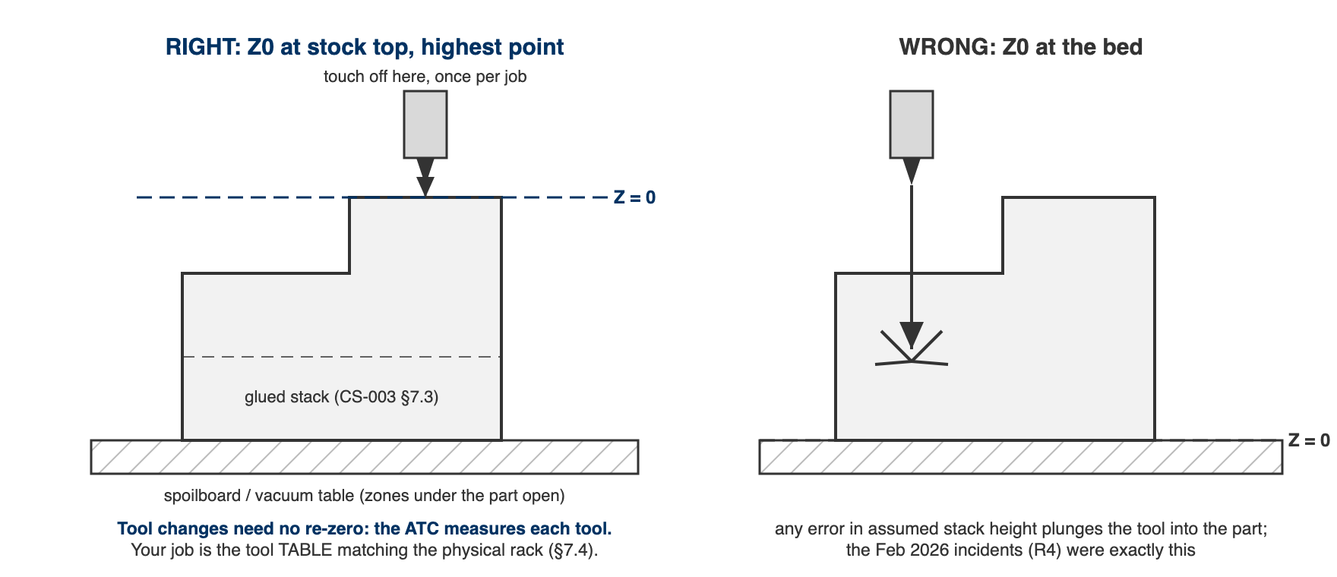
Figure 1. Z-zero, right and wrong. Left: touched off once per job at the highest point of the stock. Right: zeroed at the bed, where any error in assumed stack height is a plunge into the part.

7.5 During and after
- Stay with the machine; dust management per RFS rules.
- Record actual machining time on the WO (this is how next season's estimates get good).
- Check scribes/surfaces before releasing the vacuum; rework is easiest while the part is still located.
- Clean up, hand the room back better than you found it. The RFS relationship is our machining capacity.
- Engrave the mold ID on the back face before releasing the vacuum: 6 mm cap height, 1.0 mm deep, single-line font, 3.175 mm ball or 90° V-bit. The machine is set up and the part is fixtured, so it costs about 90 seconds.
- Mold goes to cleaning and sealing per CS-004; update the mold record's location.
⚠ CAUTION: The engraving is the record of record (CS-001 §7.4). It survives IPA, acetone, four coats of wax, PVA, sanding, the printed label falling off, and the label printer being broken. Every other way a mold is identified is a convenience wrapped around this one, which is why it is cut while the setup still exists rather than "later".

8. Quality checks / acceptance criteria
Check | Target | Method | Record where
Booking under actual operator | Always | Lead spot-check | —
Z zeroed from stock top (once/job); tool table matches rack | Every run | Operator; buddy check on first solo runs | WO step initials
Hand-push test on tall/small-footprint stacks | Before every such run | Operator | WO step notes
First-cut watch | First 5 min minimum | — | —
Actual vs estimated machine time | Recorded | Machine log | WO
Surface/scribe quality | Scribes crisp, no unexpected steps | Visual before releasing vacuum | WO qualityChecks

9. Records
WO machining step: operator, date, slot, estimate vs actual, tool list, incidents. Actual times feed the capacity model. ~2 molds/week was SN5 reality on a worse machine; find out what this one actually does instead of assuming.

Appendix: the Shopbot era (why this doc exists)
Jacobs Shopbot: per-person daily slots, ShopbotBot morning scramble, 3-reservation caps, trading slots with other teams, a ~3″ cut depth that forced tall molds to be sectioned and re-glued, manual tool changes with a re-zero every time, and tape/nail workholding (tape thickness literally showed up as Z error across a sheet). We out-demanded the system, block-booked through multiple members, and on 2026-02-23 Jacobs staff formally objected. The ShopSabre fixes the access problem and most of the setup failure modes: vacuum table kills the tape-Z-error problem, the ATC kills the forgot-to-re-zero problem, 6″ of cut depth kills most mold sectioning. It does not fix physics, though; one machine, bursty demand. The habit that transfers is forward capacity planning: estimates on WOs, booking at CAM start, machine load in the weekly summary.

